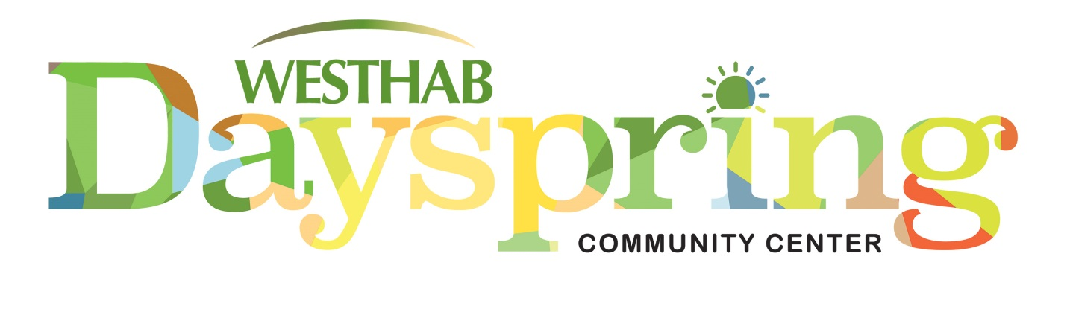

**Mobile Food Truck Distribution Dates:**

**March 26th**

**April 23rd**

**May 28th**

**June 25th**

***New Distribution Site***

***Castle Royale Parking Lot***

***Address: 92 Waverly St***

***Yonkers, NY 10701***

All distributions are on a Thursday @ 12noon